Programming with Python and Java Laboratory

CS 29008

Spring 2023-24

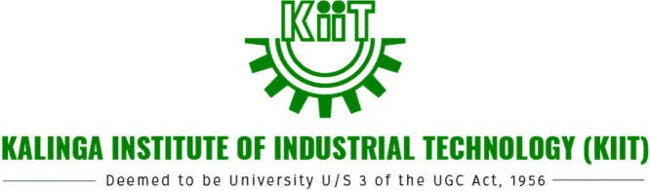

**School of Electronics Engineering** Name: Roll No.:

Section: Student Signature: